12th March 2025

Dear Year 11 Parents and Carers

Mock Exam Results & Important meeting for all Year 11 Parents and Students

On Wednesday, 19th March from 5.30-6:30pm, we would like you and your child to attend a presentation about the remainder of their academic year including examinations and collect Mock Exam results. This will include details of everything you need to know to ensure they can be successful in the exams and beyond.
At the meeting we will provide information and guidance on:

- Mock Results
- Home Run Booklets (detailing topics to be covered in and out of class before the exams)
- Summer Exam timetables
- Updated personalised GCSE exam timetable
- Revision/Period 6

Selected students will have a 1:1 session with a senior member of staff to set out support ahead of the summer exams. Staff will be available to discuss the exams and Mock results after a short presentation.

As a reward for your continuing support each parent and Year 11 child who attends will be entered into a draw for one of the following prizes:

- 10 x £20 Just Eat vouchers
- 2 x free tickets to Leavers’ Ball 2025 (providing criteria for attendance are met)

Should you have any questions regarding the contents of this letter, please get in touch with me via Class Charts or at s.cavanagh@pcs.hants.sch.uk

Yours faithfully

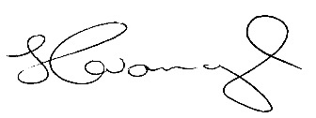

Stuart Cavanagh
Assistant Headteacher

